表1 零电流法测定h和ν₀ 光阑孔Φ = 4 mm
波长λ (nm) |  | 365 | 405 | 436 | 546 | 577
频率ν (×10¹⁴ Hz) |  | 8.214 | 7.408 | 6.879 | 5.49 | 5.196
截止电压  -U_{S} (V) | 1 | 1.697 | 1.264 | 1.075 | 0.557 | 0.451
 | 2 | 1.698 | 1.261 | 1.074 | 0.555 | 0.449
 | 3 | 1.698 | 1.260 | 1.075 | 0.554 | 0.450
 | 4 | 1.698 | 1.260 | 1.075 | 0.553 | 0.448
 | 平均值 | 1.698 | 1.261 | 1.075 | 0.555 | 0.450

表2 I-U关系数据
λ = 436 nm，光阑孔Φ = 2 mm
U_{AK} (V) | I 示数 | I 量程 | U_{AK} (V) | I 示数 | I 量程 | U_{AK} (V) | I 示数 | I 量程
-4.0 | -13.7 | 10⁻¹³ A | 2.0 | 47.1 | 10⁻¹² A | 13.0 | 26.1 | 10⁻¹¹ A
-3.5 | -12.1 |  | 3.0 | 72.1 |  | 14.0 | 27.5
-3.0 | -11.8 |  | 4.0 | 103.9 |  | 15.0 | 28.9
-2.5 | -11.1 |  | 5.0 | 127.8 |  | 16.5 | 30.5
-2.0 | -10.7 |  | 6.0 | 144.5 |  | 18.0 | 31.9
-1.5 | -9.7 |  | 7.0 | 150.5 |  | 19.5 | 33.2
-1.1 | 0.0 |  | 8.0 | 166.6 |  | 21.0 | 34.9
-1.0 | 4.7 |  | 9.0 | 186.0 |  | 22.5 | 36.6
-0.5 | 58.7 |  | 10.0 | 20.7 | 10⁻¹¹ A | 24.0 | 38.1
0.0 | 131.0 |  | 11.0 | 22.6
1.0 | 30.7 | 10⁻¹² A | 12.0 | 24.4
λ = 546 nm，光阑孔Φ = 4 mm
U_{AK} (V) | I 示数 | I 量程 | U_{AK} (V) | I 示数 | I 量程 | U_{AK} (V) | I 示数 | I 量程
-4.0 | 13.1 | 10⁻¹³ A | 2.0 | 43.1 | 10⁻¹² A | 13.0 | 197.7 | 10⁻¹² A
-3.5 | 12.8 |  | 3.0 | 66.2 |  | 14.0 | 21.0 | 10⁻¹¹ A
-3.0 | 12.4 |  | 4.0 | 82.6 |  | 15.0 | 21.9
-2.5 | 12.0 |  | 5.0 | 102.9 |  | 16.5 | 23.0
-2.0 | 11.5 |  | 6.0 | 117.3 |  | 18.0 | 24.1
-1.5 | 11.2 |  | 7.0 | 123.3 |  | 19.5 | 25.3
-1.0 | 10.9 |  | 8.0 | 136.6 |  | 21.0 | 26.4
-0.5 | 2.7 |  | 9.0 | 152.5 |  | 22.5 | 27.4
-0.4 | 0.0 |  | 10.0 | 165.0 |  | 24.0 | 28.4
0.0 | 70.3 |  | 11.0 | 174.8
1.0 | 26.0 | 10⁻¹² A | 12.0 | 187.0

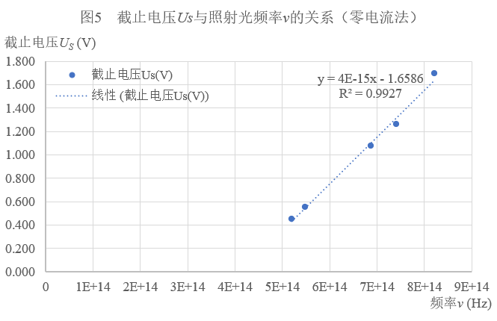

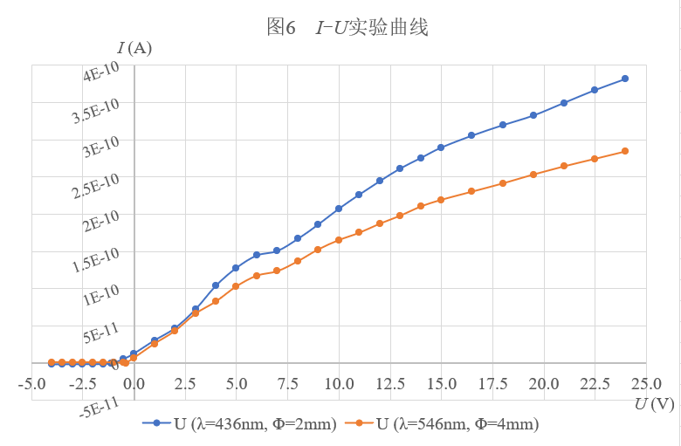

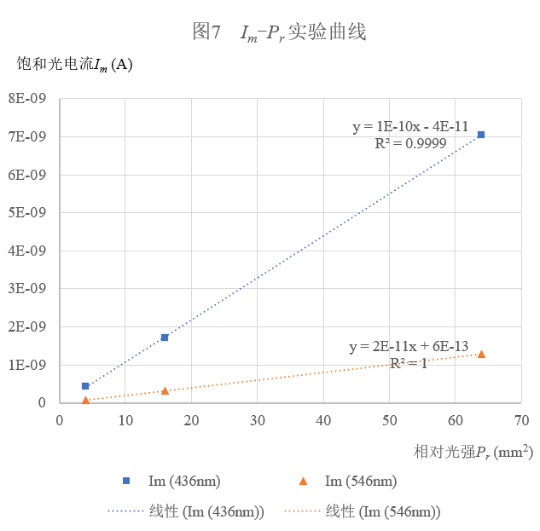
表3 I_{m}-P关系数据
436nm | 光阑孔Φ (mm) |  | 2 | 4 | 8
 | 相对光强P_{r} (mm²) |  | 4 | 16 | 64
 | I_{m}  (10⁻¹⁰ A) | 1 | 4.3 | 16.8 | 70.3
 |  | 2 | 4.2 | 17.2 | 70.9
 |  | 3 | 4.2 | 17.0 | 70.5
 |  | 平均 | 4.2 | 17.0 | 70.6
546nm | 光阑孔Φ (mm) |  | 2 | 4 | 8
 | 相对光强P_{r} (mm²) |  | 4 | 16 | 64
 | I_{m}  (10⁻¹⁰ A) | 1 | 0.8 | 3.2 | 12.8
 |  | 2 | 0.8 | 3.2 | 12.8
 |  | 3 | 0.8 | 3.2 | 12.7
 |  | 平均 | 0.8 | 3.2 | 12.8

表1 汞原子第一激发电位I-U关系数据
灯丝电压V_{F} = 1.2 V 第一栅极电压V_{G1K} = 1.3 V 拒斥电压V_{G2P} = 1.5 V 炉温T = 220 ℃
V_{G2K} (V) | I_{p} (nA) | V_{G2K} (V) | I_{p} (nA) | V_{G2K} (V) | I_{p} (nA) | V_{G2K} (V) | I_{p} (nA) | V_{G2K} (V) | I_{p} (nA)
0.0 | 0 | 15.0 | 21 | 26.5 | 42 | 38.0 | 97 | 48.9 | 136
1.0 | 1 | 15.5 | 22 | 27.0 | 45 | 38.5 | 104 | 49.0 | 136
2.0 | 2 | 15.5 | 22 | 27.5 | 51 | 38.7 | 105 | 49.5 | 133
3.0 | 2 | 16.0 | 21 | 28.0 | 59 | 39.0 | 104 | 50.0 | 129
4.0 | 2 | 16.5 | 20 | 28.5 | 67 | 39.5 | 101 | 50.5 | 124
4.5 | 2 | 17.0 | 20 | 29.0 | 72 | 40.0 | 95 | 50.9 | 123
5.0 | 2 | 17.5 | 21 | 29.2 | 72 | 40.5 | 89 | 51.0 | 123
5.5 | 2 | 18.0 | 23 | 29.5 | 71 | 40.9 | 88 | 51.5 | 125
6.0 | 3 | 18.5 | 28 | 30.0 | 66 | 41.0 | 88 | 52.0 | 131
6.5 | 3 | 19.0 | 33 | 30.5 | 60 | 41.5 | 90 | 52.5 | 138
7.0 | 3 | 19.5 | 36 | 31.0 | 57 | 42.0 | 96 | 53.0 | 145
7.5 | 3 | 19.8 | 37 | 31.2 | 56 | 42.5 | 105 | 53.5 | 149
8.0 | 3 | 20.0 | 37 | 31.5 | 58 | 43.0 | 112 | 54.0 | 151
8.5 | 4 | 20.5 | 35 | 32.0 | 62 | 43.5 | 118 | 54.5 | 150
9.0 | 5 | 21.0 | 31 | 32.5 | 70 | 43.9 | 120 | 55.0 | 147
9.5 | 6 | 21.5 | 29 | 33.0 | 78 | 44.0 | 120 | 55.5 | 143
10.0 | 7 | 21.7 | 29 | 33.5 | 85 | 44.5 | 117 | 56.0 | 142
10.5 | 8 | 22.0 | 29 | 34.0 | 88 | 45.0 | 112 | 56.5 | 145
11.0 | 9 | 22.5 | 33 | 34.2 | 88 | 45.5 | 106 | 57.0 | 149
11.5 | 10 | 23.0 | 39 | 34.5 | 86 | 45.8 | 105 | 57.5 | 156
12.0 | 10 | 23.5 | 47 | 35.0 | 80 | 46.0 | 105 | 58.0 | 161
12.5 | 11 | 24.0 | 52 | 35.5 | 74 | 46.5 | 108 | 58.5 | 166
13.0 | 12 | 24.5 | 54 | 36.0 | 72 | 47.0 | 114 | 59.0 | 168
13.5 | 14 | 25.0 | 52 | 36.5 | 74 | 47.5 | 121 | 59.2 | 168
14.0 | 17 | 25.5 | 47 | 37.0 | 80 | 48.0 | 129 | 59.5 | 167
14.5 | 19 | 26.0 | 43 | 37.5 | 88 | 48.5 | 134 | 60.0 | 165
*加粗划线代表峰值
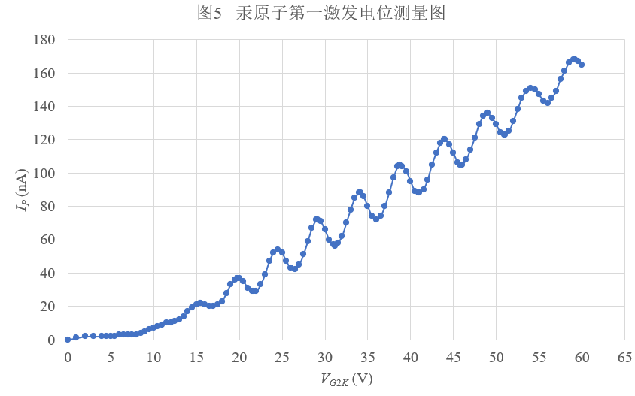

表2 汞原子高激发电位I-U关系数据
灯丝电压V_{F} = 1.3 V 拒斥电压V_{G2P} = 1.5 V 炉温T = 130 ℃
V_{G2K} (V) | I_{p} (nA) | V_{G2K} (V) | I_{p} (nA) | V_{G2K} (V) | I_{p} (nA) | V_{G2K} (V) | I_{p} (nA) | V_{G2K} (V) | I_{p} (nA)
0.0 | 0 | 8.0 | 15 | 14.0 | 26 | 20.0 | 32 | 26.0 | 40
1.0 | 0 | 8.5 | 5 | 14.5 | 19 | 20.5 | 28 | 26.5 | 41
2.0 | 0 | 9.0 | 1 | 15.0 | 14 | 21.0 | 26 | 27.0 | 40
3.0 | 0 | 9.5 | 2 | 15.5 | 12 | 21.5 | 25 | 27.5 | 40
4.0 | 0 | 10.0 | 5 | 16.0 | 15 | 22.0 | 25 | 28.0 | 41
4.5 | 3 | 10.5 | 9 | 16.5 | 16 | 22.5 | 25 | 28.5 | 41
5.0 | 5 | 11.0 | 14 | 17.0 | 16 | 23.0 | 26 | 29.0 | 42
5.5 | 9 | 11.5 | 16 | 17.5 | 19 | 23.5 | 30 | 29.5 | 44
6.0 | 14 | 12.0 | 18 | 18.0 | 24 | 24.0 | 32 | 30.0 | 47
6.5 | 14 | 12.5 | 22 | 18.5 | 29 | 24.5 | 35
7.0 | 16 | 13.0 | 26 | 19.0 | 31 | 25.0 | 38
7.5 | 18 | 13.5 | 27 | 19.5 | 33 | 25.5 | 40
*加粗划线代表U₁、U₂

